Please join Mary, Mother of Mercy Parish’s
Pro Life Ministry, and Knights of Columbus Councils #7032 and #6247
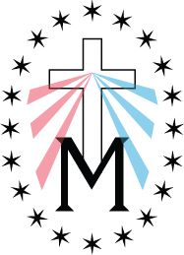
in building a
“Memorial to the Unborn”.

4” x 8” Memorial Pavers are on sale now for $50.00.
Limited quantities available, so get your pavers early!!
(Bricks hold 4 lines of 21 characters each-including spaces)

Memorialize your loved ones in this very special place!
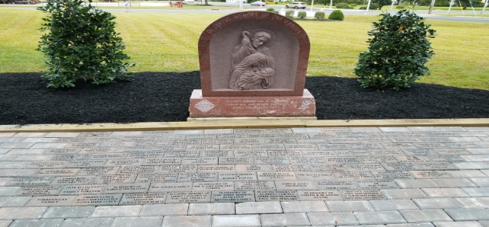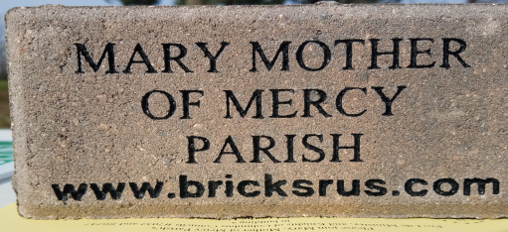
Order Online at:
https://www.bricksrus.com/order/unbornmemorial/index.php

Yes, we’d like to reserve a permanent paver. Please engrave our paver as follows:
ANY SYMBOL IS CONSIDERED ONE SPACE (PERIOD, COMMA, DASH)
ALL TEXT IS CENTERED UNLESS OTHERWISE NOTED
4 x 8 Brick

PLEASE RETURN THIS FORM AND YOUR CHECK PAYABLE TO:
Mary, Mother of Mercy Parish, 500 Greentree Road, Glassboro, NJ 08028

Name: Phone:

Address:

City: State: Zip:

Email Address: Amount Paid: $
If you have any questions, please call the Parish Office at (856) 881-0909.

